83.02.17a
From James Smith
RB MSS M1, Library, Royal Botanic Gardens Melbourne.

6 Cecil Place,
near Town Hall,
Prahran, 17/2/83.
Respected Sir,
I shall feel greatly obliged if you will kindly inform me whether you are aware if the Kidney Bean (of which I enclose a photograph, &c.) has been introduced and grown in this colony. Some seeds (small, nearly round, white, with black blotch at germ) were given to me as a curiosity two or three years since, and I have grown them the last two seasons, and believe they will furnish a very valuable addition to our cuisine — being remarkably prolific, not at all stringy, when cooked, and of fine flavour. I shall be glad to furnish you with further particulars if you will not deem it too much trouble
Yours very respectfully
Jas H. Smith
Engraver &c.

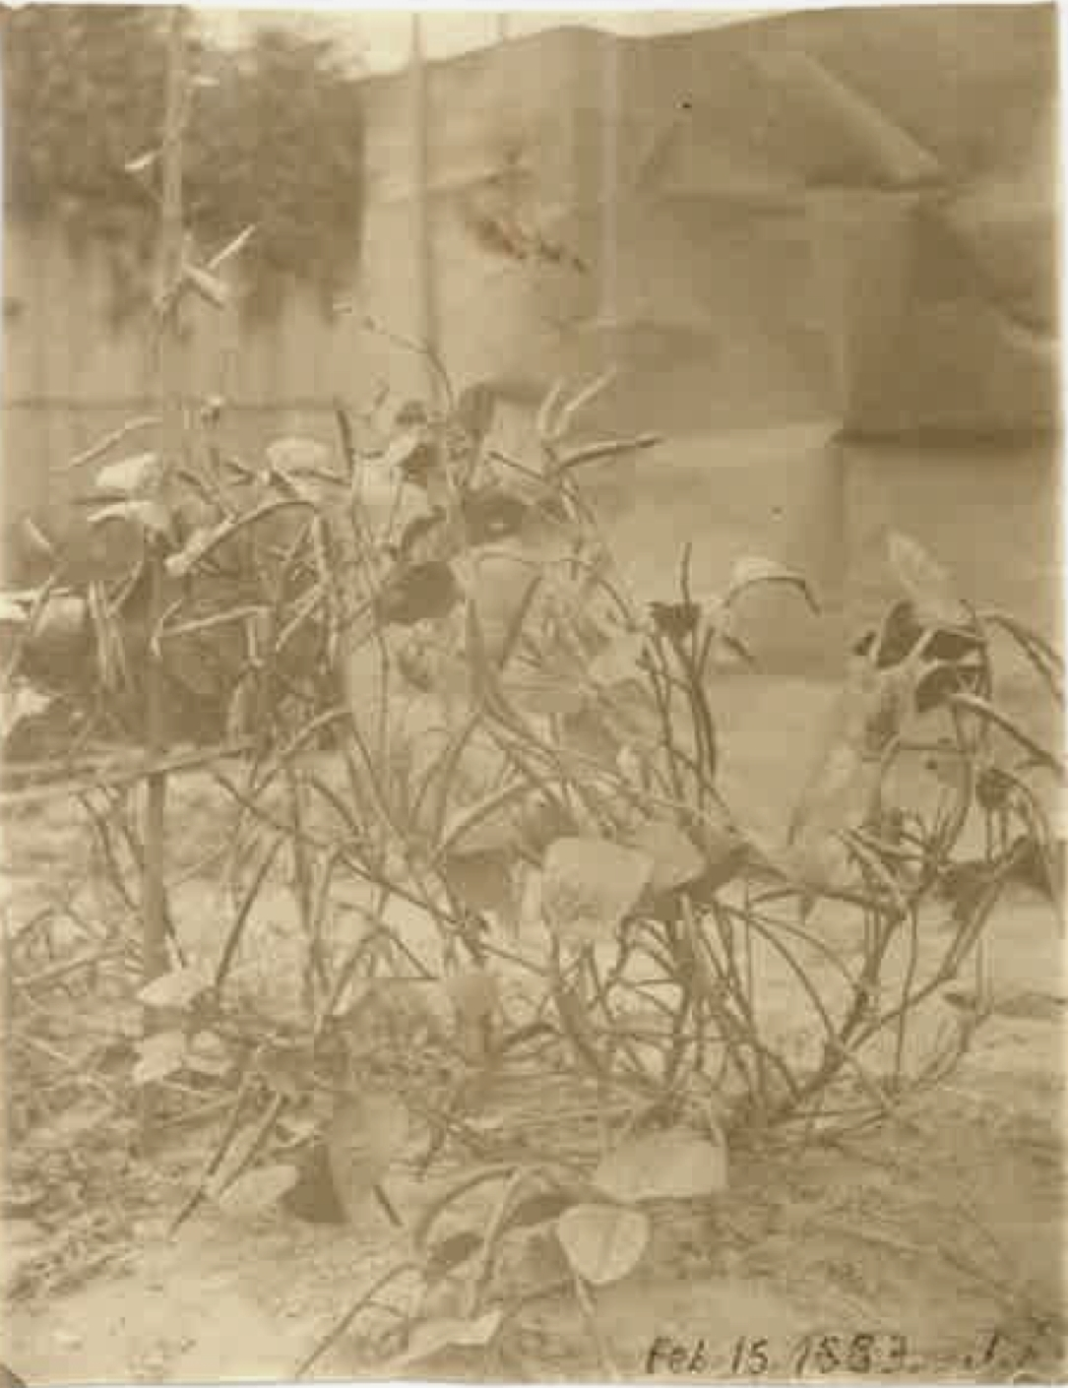
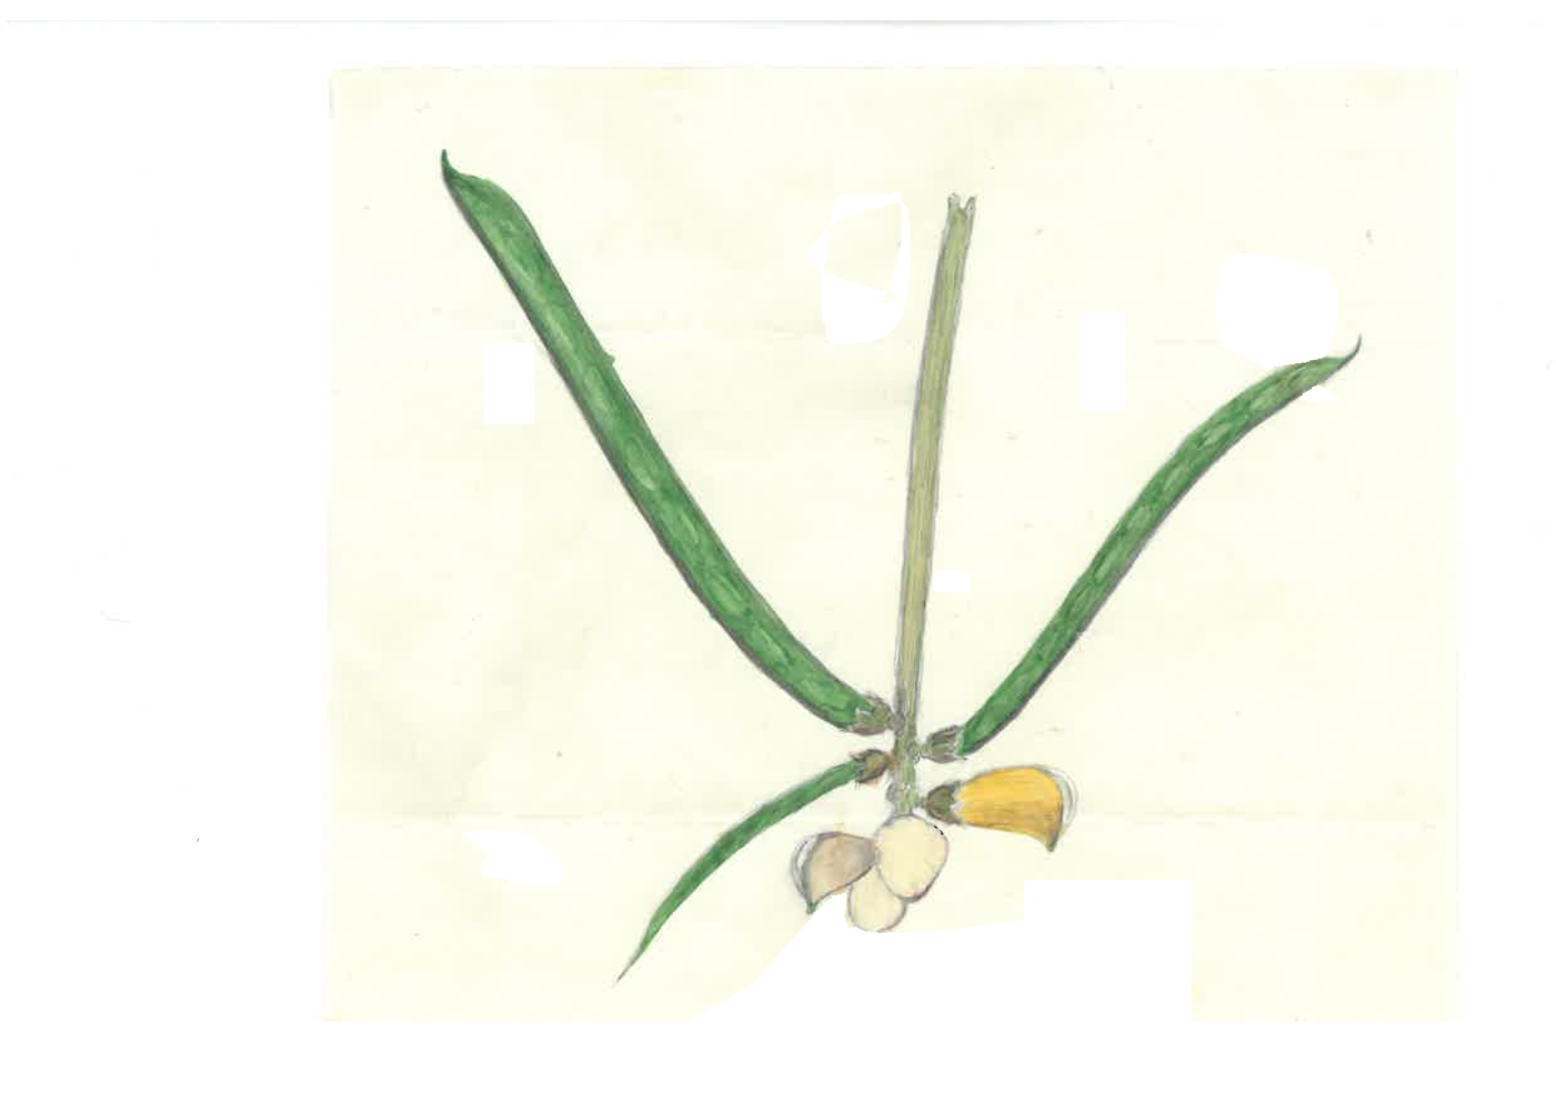

MS found with a specimen of Vigna luteola (MEL 1577012). The correspondent is James Smith (1815-1899). MS is accompanied by a photograph, now very yellowed, dated and initialled: 'Feb 15. 1883. J. S.': 83-02-17a_image01.jpg and a small watercolour of part of the plant showing flowers and pods on the stem: 83-02-17a_image02.jpg
Melbourne.

